**Practical 1**

**Aim:**

Write a java program using java.net library iterative echo client-server. (TCP Protocol)

**Description:**

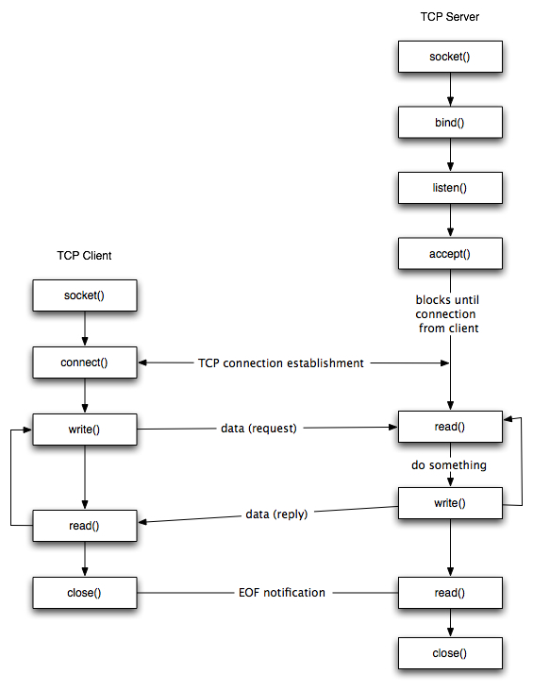

Fig 1. Iterative Echo Client-Server Using TCP

**Program code:**

**EchoClient:**

//TCP Client

**import** java**.**io**.*;**

**import** java**.**net**.*;**

publicclassEchoClient**{**

publicstaticvoid main**(**String**[]**args**)throws**IOException**{**

String serverHostname**=new** String **(**"127.0.0.1"**);**

**if(**args**.**length**>**0**)**

serverHostname**=**args**[**0**];**

System**.**out**.**println**(**"Attemping to connect to host "**+**

serverHostname**+**" on port 10007."**);**

Socket echoSocket**=null;**

PrintWriter out **=null;**

BufferedReader in **=null;**

**try{**

// echoSocket = new Socket("taranis", 7);

echoSocket**=new** Socket**(**serverHostname**,**10007**);**

out**=new**PrintWriter**(**echoSocket**.**getOutputStream**(),true);**

in**=new**BufferedReader**(new**InputStreamReader**(**

echoSocket**.**getInputStream**()));**

**}catch(**UnknownHostException e**){**

System**.**err**.**println**(**"Don't know about host: "**+**serverHostname**);**

System**.**exit**(**1**);**

**}catch(**IOException e**){**

System**.**err**.**println**(**"Couldn't get I/O for "

**+**"the connection to: "**+**serverHostname**);**

System**.**exit**(**1**);**

**}**

BufferedReaderstdIn**=new**BufferedReader**(**

**new**InputStreamReader**(**System**.**in**));**

String userInput**;**

System**.**out**.**print**(**"input: "**);**

**while((**userInput**=**stdIn**.**readLine**())!=null){**

**if(**userInput**.**equals**(**"Bye."**))**

**break;**

out**.**println**(**userInput**);**

System**.**out**.**println**(**"echo: "**+**in**.**readLine**());**

System**.**out**.**print**(**"input: "**);**

**}**

out**.**close**();**

in**.**close**();**

stdIn**.**close**();**

echoSocket**.**close**();**

**}**

**}**

**EchoServer:**

//TCP Server

**import** java**.**net**.*;**

**import** java**.**io**.*;**

publicclassEchoServer

**{**

publicstaticvoid main**(**String**[]**args**)throws**IOException

**{**

ServerSocketserverSocket**=null;**

**try{**

serverSocket**=new**ServerSocket**(**10007**);**

**}**

**catch(**IOException e**)**

**{**

System**.**err**.**println**(**"Could not listen on port: 10007."**);**

System**.**exit**(**1**);**

**}**

Socket clientSocket**=null;**

System**.**out**.**println**(**"Waiting for connection....."**);**

**try{**

clientSocket**=**serverSocket**.**accept**();**

**}**

**catch(**IOException e**)**

**{**

System**.**err**.**println**(**"Accept failed."**);**

System**.**exit**(**1**);**

**}**

System**.**out**.**println**(**"Connection successful"**);**

System**.**out**.**println**(**"Waiting for input....."**);**

PrintWriter out **=new**PrintWriter**(**clientSocket**.**getOutputStream**(),true);**

BufferedReaderin**=new**BufferedReader**(new**InputStreamReader**(**clientSocket**.**getInputStream**()));**

String inputLine**;**

**while((**inputLine**=**in**.**readLine**())!=null)**

**{**

System**.**out**.**println**(**"Server: "**+**inputLine**);**

out**.**println**(**inputLine**);**

**if(**inputLine**.**equals**(**"Bye."**))**

**break;**

**}**

out**.**close**();**

in**.**close**();**

clientSocket**.**close**();**

serverSocket**.**close**();**

**}**

**Input Output:**

